Table of Content

1.Abstract ……………………………………………………………… 3

2.Background and Justification.……………………………………... 3

3.Project Methodology………....………………………………………4

4.Project Scope………………....……………………………………...6

5.High Level Project Plan……....……………………………………..7

6.Reference…………………………………………………………..…7

<AL-MAKHARIJ>

(Project Proposal)

Project Code
<Group 11>

Project Advisor
<Dr. Saad Razzaq> (internal)
<Ms Izzah Alam> (external)

Project Manager
<Dr. Fahad Maqbool>

Project Team
<Ms Muteeah Fatima BSCS51F22R035 (Lead)
Ms Samreen Zahra BSCS51F22R027 (Member)>

Submission Date
<May 21,2026>

Abstract

Proper recitation of the Quran, adhering to the rules of Tajweed, is essential for preventing mistakes during recitation. It requires significant effort to master Tajweed yet most of us face difficulty to find proper tools and guidance to learn it. Automatic evaluation of recitation can address these challenges by providing quick feedback and aiding independent practice. “AL-MAKHARIJ” provides a simplified solution to master Tajweed with interactive lessons, authentic audio recitation and speech recognition for real time audio testing and evaluation. This project focuses on fine-tuning a pre-trained DL model to classify Tajweed rules trained on authentic Qari’s recitations and publicly available datasets, which provide quick corrective feedback offering a trustworthy solution. The application uses a Deep Learning wav2vec2-espeak-NG model to detect phonetic errors in pronunciations of Tajweed rules in user’s recitation. Recorded audio is processed and forced aligned according to given phonetic sequences and converted to text and ultimately to phoneme sequences for comparison and feedback. The main goal is to minimize the gap between traditional learning and modern digital techniques and tools to provide better experience. The idea not only offers a scalable solution for Islamic education but also contributes academically by effectively integrating AI with real world.

Background and Justification

Tajweed is a system of pronunciation that regulates how Arabic sounds are pronounced along with their acoustic properties. The proper recitation of QURA’N requires proper sticking to the Tajweed rules. These rules play a crucial role in preserving the precise recitation of the sacred text.

Access to experienced mentors is often limited. Moreover, there are many other sources which offer learning facilities such as online courses, video tutorials, and certain apps like “Tafseer-e-Usmani” [1].There is also an application similar to ours available at playstore, but it does not specifically elaborates the feedback about mistakes[2]. Yet they provide unidirectional approach and lack the quick feedback and self- assessment feature using real time audio recordings. So, most of the learners struggle to get their pronunciation mistake fixed. Moreover, the well-known app “Duolingo” provides the best platform to learn different languages including Arabic but mere learning of language basics does not help to master the proper Tajweed rules.

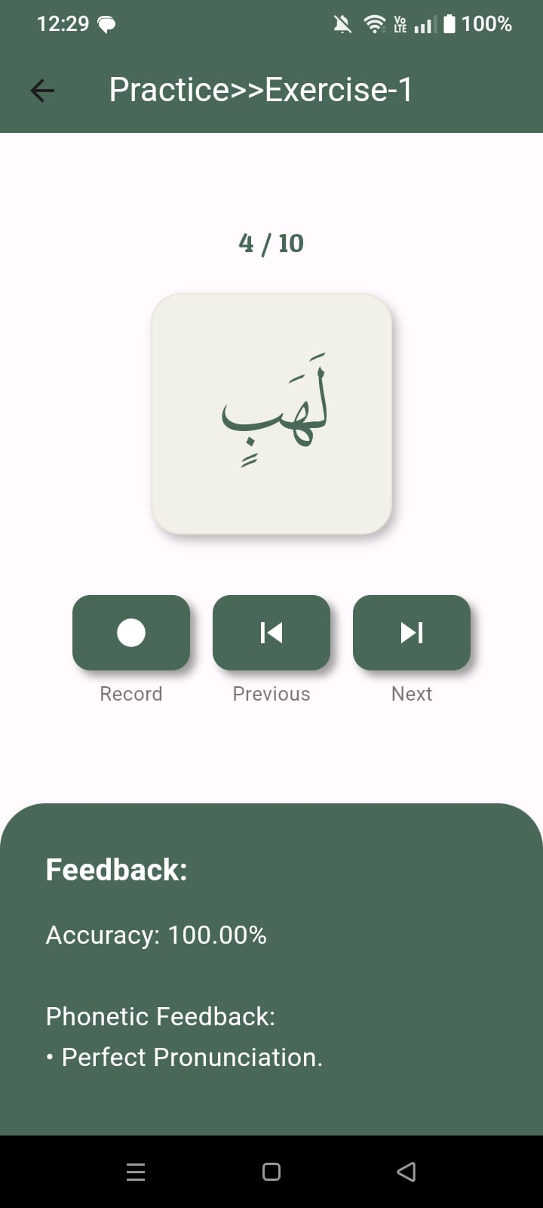
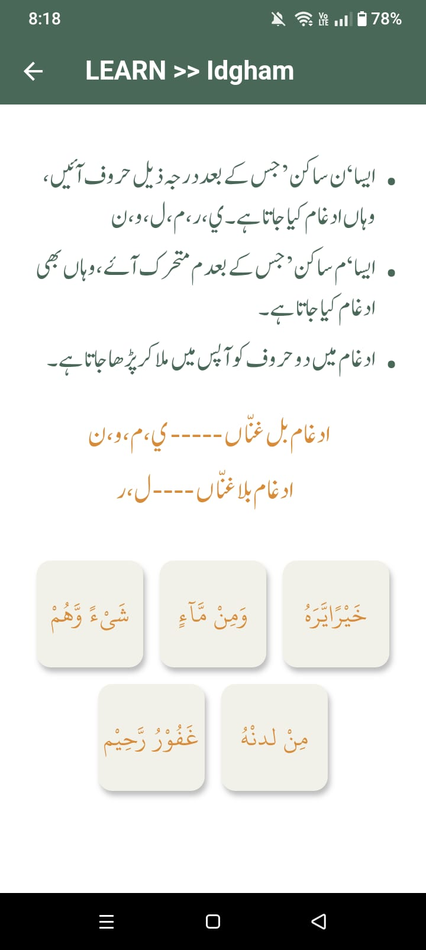
The integration of artificial intelligence (AI) for the automated assessment of recitation can address many of these challenges. The app “Al-Makharij” provides chapter wise learning of Tajweed rules from authentic tutor (Ali Ehtisham) and Quran Guides. The integrated Qari’s audio recordings will provide proper understanding of pronunciation. The user recording option makes an effective use of deep learning models to provide an interactive and realistic experience for users [3]. Additionally, real-time feedback through speech processing technologies will help make strong grip and overcome the deficiencies. The app not only minimizes the gap between traditional learning and digital technology yet also provides an accessible and user-friendly approach to address the problem.
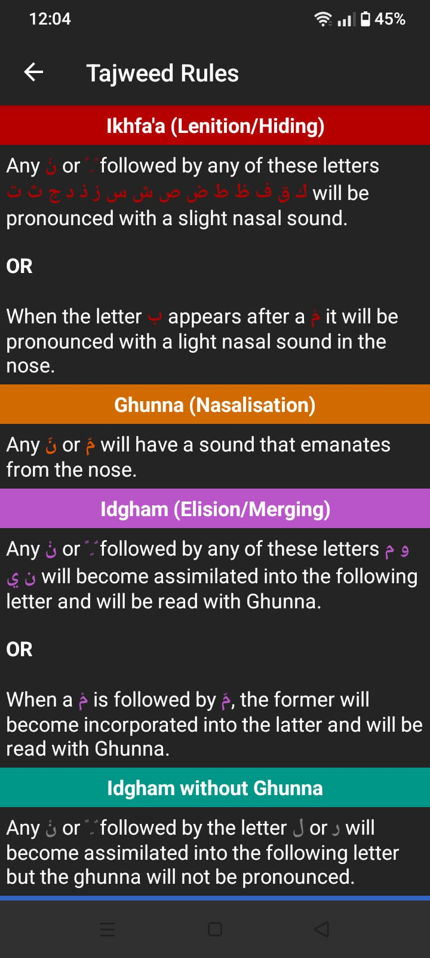
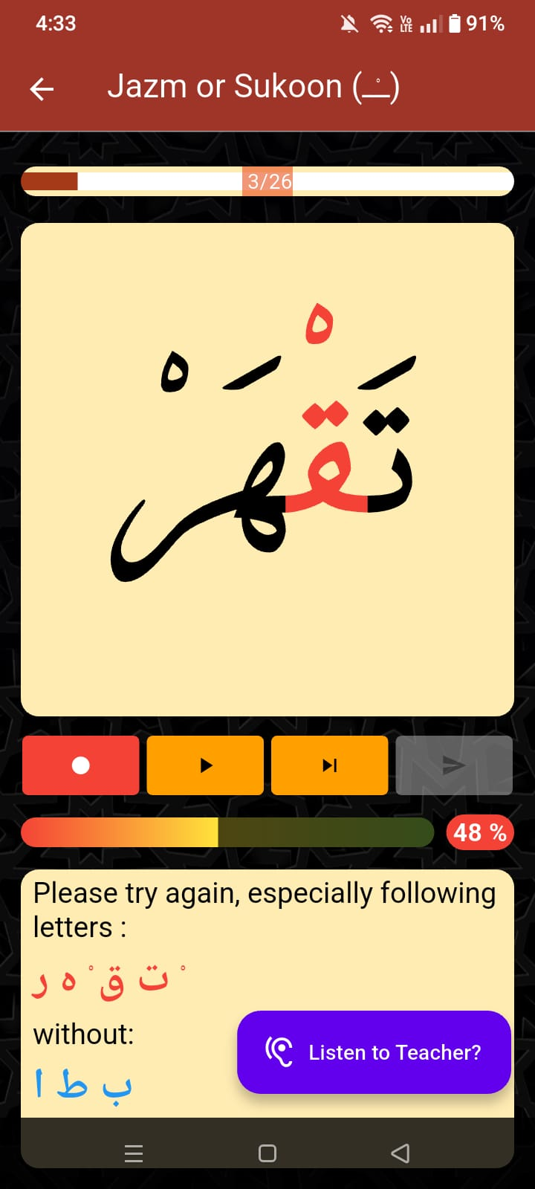
[1] [2] [3]

Project Methodology

1. Data Collection:
- Collect and Embed Qari’s pre-recorded voice against each Tajweed rule for learning.
- Generate phoneme sequences for each Arabic word using espeak for authentic IPA Latin phonemes.
- Prepare the metadata for each word including the word’s unique id, Arabic text, phoneme sequence and the rule being used.

2. Data Preprocessing:
Recorded audio will be processed and converted into text. This text will be again processed by the model which will break the text into time frames and convert each frame into its related phoneme. These phonemes are used to identify the error in pronunciation, by comparing extracted ones with the reference phonemes.

3. AI Model Fine-Tuning:
The wav2vec2 model is pretrained on bulk of Arabic text and hours of recitations. We fine-tuned it to map raw Arabic audio directly to espeak-NG phonemes. This allows us to do forced alignments of the text to generate precise timestamps for each individual letter or character, which are then analyzed for error detection and accuracy

Architecture:
- Wav2Vec2 Transformer Inference
- CNN Encoder, Logit Generation
- CTC Decoding and Forced Alignment
- Phoneme Mapping
- Acoustic Analysis and Feedback
Tools & Libraries: Python, transformers, pyctcdecode, librosa, torch, VS code.
4. AI Model Testing:
The fine-tuned model will be tested on recordings from users varying in age, sound pitch and frequency. Accuracy will be measured to check how well it predicts correct or incorrect pronunciations.
5. Frontend:
We will develop simple and interactive mobile app using Flutter and Figma, where users can learn Tajweed rules and practice them to test their learning.

6. Backend:
Handles user’s audio processing and API calls management, loads the model and preprocessor to check pronunciation errors and returns the JSON response to display the feedback to user.

7. System Integration and Testing:
All app components (frontend, backend, AI model) will be integrated and tested to ensure correct pronunciation evaluation and data handling.

8.Deployment:
- The flutter app will be compiled into android APK file (will be deployed only for Android). Team members and evaluators can install the APK manually without Play Store using “sideloading” to test it on actual devices.
- Hosting the backend temporarily on free/academic cloud services.
- The app communicates with the backend via APIs for pronunciation evaluation and feedback.
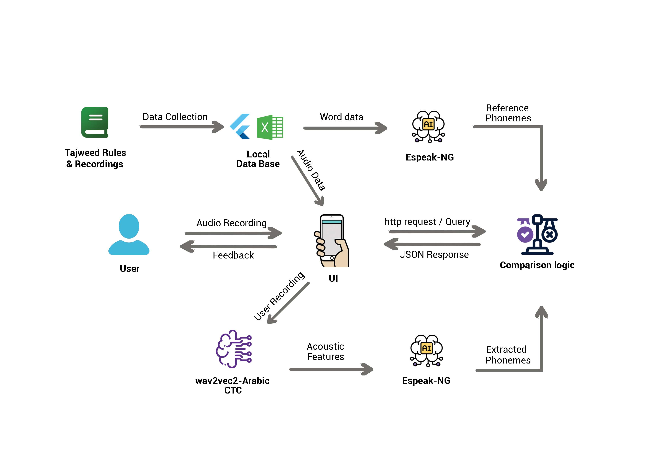
figure 1.1 workflow diagram

Project Scope

Included Scope:
- The system will provide all the basic Tajweed rules in the form of chapters. Each chapter will comprise of written rules, and a few sample examples to clear the rules.
- The examples will be integrated with the authentic Qari voice recordings to precisely learn pronunciation.
- Practice exercises with real-time recordings option to evaluate using comparison with preset audio recitation.
- Real-time feedback mechanism to guide learners in correcting mistakes.

Excluded Scope:
- The user recording functionality will be valid just for the basic rules and few related examples.
- System will not produce a 100 percent accurate result rather than 60 to 70 percent accuracy will be met.
- Will not provide certifications or official Islamic accreditation.
- No full replacement of in-person Quran tutors.
- No extensive gamification features.

High level Project Plan

Phase | Weeks | Duration | Start Date | End Date
Planning | Week 1 – 5 | 5 weeks | 1 Sept 2025 | 5 Oct 2025
Data Collection | Week 6 – 7 | 2 weeks | 6 Oct 2025 | 19 Oct 2025
Preprocessing | Week 8 – 9 | 2 weeks | 20 Oct 2025 | 2 Nov 2025
Model Design | Week 10 – 13 | 4 weeks | 3 Nov 2025 | 30 Nov 2025
Model Training | Week 14 – 20 | 7 weeks | 1 Dec 2025 | 18 Feb 2026
Backend / Frontend | Week 21 – 29 | 9 weeks | 14 Jan 2026 | 22 March 2026
Integration & Testing | Week 30 – 32 | 3 weeks | 23 March 2026 | 13 April 2026
Deployment | Week 33 –- 34 | 2 weeks | 14 April 2026 | 28 April 2026

References
[1] Q. Xu, A. Baevski, and M. Auli, “Simple and Effective Zero-shot Cross-lingual Phoneme Recognition,” arXiv preprint arXiv:2109.11680, 2021. Available: https://arxiv.org/pdf/2109.11680
[2] Author(s), “Title of the Paper,” arXiv preprint arXiv:2509.00094, 2025. Available: https://arxiv.org/abs/2509.00094
[3] Author(s), “Title of the Paper,” arXiv preprint arXiv:2511.17477, 2025. Available: https://arxiv.org/pdf/2511.17477

[3] Duolingo, Duolingo: Language Lessons, Version 6.220.2, Google Play Store, 2025. [Online]. Available: https://play.google.com/store/apps/details?id=com.duolingo

Software Requirements Specifications

<AL-MAKHARIJ>

Project Code: Group 11

Internal Advisor: Dr. Saad Razzaq

External Advisor: Ms. Izzah Alam

Project Manager: Dr. Fahad Maqbool

Project Team: Ms. Samreen Zahra BSCS51F22R027(member)
Ms. Muteeah Fatima BSCS51F22R035(lead)

Submission Date:

_____________________
Project Manager’s Signature
Document Information

Category | Information
Customer | CS & IT, UOS
Project | <AL-MAKHARIJ>
Document | Requirement Specifications
Document Version | 1.0
Identifier | PGBH01-2020-RS
Status | Draft
Author(s) | <Samreen Zahra, Muteeah Fatima>
Approver(s) | PM
Issue Date | Sept. 15, 2020
Document Location
Distribution | - Advisor  - PM  - Project Office

Definition of Terms, Acronyms and Abbreviations

This section should provide the definitions of all terms, acronyms, and abbreviations required to interpret the terms used in the document properly.

Term | Description
ASP | Active Server Pages
RS | Requirements Specifications
Wav2Vec2 | A pretrained speech processing model by Facebook
IPA | International Phonetic Alphabet
Phoneme | Smallest unit of sound in one language
API | Application Programming Interface
Makharij | Arabic term for articulation points of letters
Tajweed | Rules governing correct Quran recitation

Table of Contents

- INTRODUCTION 12
  - Purpose of Document …………………………………………….. 12
  - Project Overview………………………………………………….. 12
  - Scope………………………………..…………………………….. 13

- OVERALL SYSTEM DESCRIPTION 13
  - User Characteristics……………………………………………….. 13
  - Operating Environment………………………………………..….. 14
  - System Constraints………………………………………………... 14

- EXTERNAL INTERFACE REQUIREMENTS 15
  - Hardware Interfaces……………………………………………….. 15
  - Software Interfaces………………………………………………... 16
  - Communication Interfaces………………………………………….16

- FUNCTIONAL REQUIREMENTS 16

- NON-FUNCTIONAL REQUIREMENTS 17
  - Performance Requirements ………………………………..…….. 17
  - Safety Requirements………………………………………..…….. 17
  - Security Requirements………………………………………...….. 17
  - User Documentation…………………………………………….... 17

- ASSUMPTIONS AND DEPENDENCIES 18

- SYSTEM ARCHITECTURE 19

- USE CASES 19
  - Use case Diagrams………………………………………………... 19
  - Use Case Description………………………………………….….. 20

- GRAPHICAL USER INTERFACES 26

- HIGH LEVEL DESIGN 30
10.1. ER Diagram……………………………………………………... 30
10.2. Data Dictionary ………………………………………...……….. 31
    - Data 1……………………………………………………... 31
    - Data 2…………………………………………………..….. 31
    - Data n………………………………………………..…….. 32

- REQUIREMENTS TRACEABILITY MATRIX 33

- RISK ANALYSIS 33

- COST ESTIMATION SHEET 34

- REFERENCES 34

- APPENDICES 35

Introduction

  - Purpose of Document
The purpose of this SRS (software requirement specification) document is to describe the concept, methodology, functionality, scope and use cases of Al-Makharij, an AI-powered application designed to assist learners in mastering Tajweed, the system of rules for correct pronunciation of Arabic language. This document will describe the architecture of the system, the technologies implemented, and the development processes as suggested by developers. The document is intended for a variety of audiences including developers who may need to further extend the system, the supervisor and the academic evaluators who will review the project’s methodology for grading or evaluation purposes. The development team will follow this plan to design and develop the system. The end users will use it for learning and practice purposes. This document provides all the necessary details to cater needs of all type of audiences who want to benefit from the system.

  - Project Overview
The project under study “Al-Makharij” is a mobile application that provides a simplified solution to master Tajweed with interactive lesson, authentic audio recitation and speech recognition for real time audio testing and evaluation. This project focuses on developing a deep learning model to classify Tajweed rules trained on private dataset, which provide quick corrective feedback offering a trustworthy solution. There are plenty of sources that provide learning facilities such as online courses, video tutorials, and certain apps like “tafseer-e-Usmani”. Yet they provide unidirectional approach and lack the quick feedback and self- assessment feature. The integration of artificial intelligence (AI) for the automated assessment of recitation in “Al-Makharij” addresses this gap by providing real time feedback through speech processing technologies. Moreover, it provides a very interactive interface to learn proper makharij from embedded recitation of qualified Qari, independent of in person tutoring.
Users who already know the basics of recitation but struggle to pronounce the words correctly will use this system. The users will interact with the application’s interface via separate sections for learning and practice. The learn section will provide the written rules and audio examples to clarify the rules. The practice section is innovated with DL model that will analyze the input, compare it with reference recitations stored in the database, and provide immediate corrective feedback.

Goals:
- Develop self-learning Tajweed app with integrated AI for real-time feedback.
- Ensuring trust and accuracy using reliable resources.
- Provide a scalable and user-friendly platform.
- Portray academic significance of AI in Islamic education.

Benefits:
- Accessible platform for Tajweed learning.
- Real-time feedback for corrective learning.
- Independent and interactive learning without in person tutoring.
  - Scope
Included Scope:
- The system provides all the basic tajweed rules in the form of chapters.
- The examples are integrated with the authentic Qari recitations to precisely learn pronunciation.
- Practice exercises with real-time recording option to evaluate using comparison with preset audio recitation.
- Real-time feedback mechanism to guide learners in correcting mistakes.
- Phoneme Feedback for all similar letters.
- Tajweed based feedback for the four rules of Noon Sakin and Tanween.

Excluded Scope:
- The user recording functionality is valid just for the basic rules and few related examples.
- System is expected to provide accuracy of range 70-75%, as complete accuracy cannot be guaranteed due to complexity of Arabic phonemes.
- No certifications or official Islamic accreditation.
- No full replacement of in-person Quran tutors.
- No extensive gamification features.

Overall System Description
This AI-powered Tajweed Analysis System is a modernized mobile based application designed to improve and update the way of Quran learning and practice. The system works in a real time environment where users interact with mobile UI to record their recitation of specific Quranic words for mistake evaluation and feedback analysis.
The architecture of this system consists of a FastAPI backend, which is hosted on Hugging Face that serves as the computational base, which utilizes the specified Wav2Vec2 model for in-depth phonetic analysis. The model provides immediate corrective feedback on phonetic errors and the four rules of noon sakin. By minimizing and bridging the gap between traditional and modern AI based learning, our system provides accessible, smart and scalable platform for improving recitation limitizing the need for a physical instructor.

  - User characteristics
Primary Users:
Learners: They will use the app to learn tajweed rules, practice recitations, and will get immediate feedback at runtime.
Secondary Users:
Qari: Provides pre-recorded audio for each tajweed rule. His interaction with the system is one
time. These recordings would help users to learn tajweed rules before practice, for correct pronunciation.
Admin: Responsible for embedding Qari recordings and training the AI model on these recordings. His interaction with the system is also one time.
Importance:
App Learners are the most important ones, as the app is mainly designed to help them learn Tajweed rules.

  - Operating environment
Hardware Requirements:
- Mobile phones for users.
- Laptop required for admin tasks (embedding Qari recordings and AI model training).
- Internet Connection for Audio Processing and Feedback.
Operating System:
System requires Android operating system for mobile devices and Windows operating system for Laptops.
Development Tools and Technologies:
- Python programming language for backend.
- Facebook, hugging face, wav2vec2 model for audio to text conversion.
- Flutter will be used to build the Frontend of the mobile app
- Android Studio Used to test the mobile app
- Visual Studio Code for Backend Coding.
- Hugging Face and GitHub for model Deployment.

  - System constraints
• Software constraints:
- Mobile app must have built using Flutter with Android operating system.
- AI model must have developed using Python with library Tensorflow.

• Hardware constraints:
- Mobile must have Microphone and internal storage.
- There must be a Laptop for model training.
- Internet Connection must be good and stable.
• Cultural constraints:
- App interface and tajweed rules description must support English or Urdu for better understanding.
• Legal constraints:
- Permissions should have granted to system to record and process user’s voices.
- System should ensure privacy of user’s recordings.
• Environmental constraints:
- Users should record their voices in a quiet environment in order to avoid noise in recordings and to get better feedback.
• User constraints:
- App is specifically designed for beginners with simple interface and navigation.
• Off-the-shelf components constraints:
- Audio processing libraries and TensorFlow must be compatible with development OS.

External Interface Requirements
This section describes the hardware and software connections required by the system to process the raw audio from the user and generate the corrective feedback on mobile’s interface.

  - Hardware Interfaces
Mobile Microphone: The system uses mobile’s microphone to record the audio recitation.

Audio Capture Specifications: Recordings are taken at a sample rate of 16kHz Mono wav files to fulfil the input criteria for machine learning models.

Processor/Memory: A smartphone of at least 4GB of RAM is required to handle real-time audio recording and processing for high fidelity feedback generation.

  - Software Interfaces
FastAPI Backend: The primary interface that receives audio files and returns JSON formatted feedback to display on interface.

Flutter Frontend: For engaging and compelling user interface for learning rules, listening to the sample recording, recording real-time recitation and visualizing corrective feedback.

Hugging Face Spaces: A hosting platform for all the related models used in the backend, requiring HTTP protocol for secure connection.

Wav2Vec2 Model: Interfaces with raw audio to perform CTC based phonetic decoding and embedding extractions.

  - Communications Interfaces
HTTP Protocol: provides all the communications between the flutter Application and the backend to assure security of data.

JSON data exchange: Data exchanged in flat JSON format, which contains the keys like Phonetic Feedback, Tajweed Feedback, Target and User Sequences.

Multipart Request: Used in transmitting .wav files from mobile device to the server for tajweed analysis.

Functional Requirements
This section describes the main functionalities and specific behaviors, providing the detailed information about how a user interacts with the application and how the system’s backend processes those human interactions.

1. Real-time Audio Recording and capturing:
1. The system allows the user to record recitation at runtime, for a specific word selected from the listed words in exercises.
2. Audio is captured at the sampling rate of 16 kHz and is saved in .wav format to assure the proper integration with machine learning model.
3. The system takes a minor delay to ensure the file write before its transmission.

2. Phoneme Analysis and Articulation:
Backend uses a specialized Wav2Vec2 Cross-Lingual Speech Representations (XLSR-53) model for decoding phonetic sequences from uploaded audio.
The system uses CTC-based alignment to extract specific timestamps for each pronounced phoneme.
It performs comparison between extracted phenome sequence and target phenome sequence to identify articulation/tajweed errors.

3. Tajweed Rule Validation:
The system identifies specific Tajweed rules (e.g., Ikhfa, Izhaar, Idgham, Iqlaab) based on the selected word ID.

4. Feedback Reporting and Accuracy Scoring:
The system provides human understandable tajweed feedback that specifies whether the rule is correct or incorrect, and phonetic feedback that demonstrates which letters were mispronounced.

Non-functional Requirements

  - Performance Requirements:
Latency of UI: system must process user audio and provide the feedback within 4-5 sec after the user presses the “stop recording” button.

System Responsiveness: The system should maintain its responsiveness during the analysis phase, providing immediate corrective feedback to the user, while the backend handles the decoding.

Concurrent Handling: The FastAPI backend should be able to handle concurrent feedback requests from multiple users, without significant delay in response time.

  - Safety Requirements:
Error Handling: If system receives an invalid input like silence, excessive background noise, it should provide a clear, logical error message i.e try again in clear environment rather than crashing.

Stability: System should maintain data integrity during audio processing. In case of network connection error, it must provide a clean message (500 internal server Error) and re-try prompt.

Constraint Adherence: Sanitation of input audio should be performed on all recitation payloads to ensure only valid formats .wav or .mp3 have passed to the backend.

  - Security Requirements:
User Privacy: User recordings are treated as transient data. User’s data must immediately be removed from the server’s memory as soon as the feedback is returned so that privacy remains intact.

Communication Security: All types of data transmissions between the Flutter Frontend and the FastAPI backend must occur over HTTPS/TLS to prevent privacy breach on user’s private audio data.

  - User Documentation:
In App Help: The System Contains Built in description within the Lessons Module of the Application, which contains the explanation of the individual tajweed rules and how to pronounce them.
Operational Manual: A complete descriptive guide is provided for user’s convenience to understand how the phonetic feedback system works.

Assumptions and Dependencies
This section highlights the key assumptions that have made by the project team regarding the environment, users, and resources necessary for the successful operation of the AI based Tajweed Application.

  - Assumptions:

Network Availability: We assume that the user has stable internet connection during feedback evaluation because the heavy backend computations and the feedback generation is performed by backend hosted on hugging face cloud environment.

Recording Environment: We assume that the users record their audio recitation in a clean, noise free environment so that the generated feedback is correct and free from alterations.

Device Compatibility: We assume that the users run the application on a mobile device with compatible versions, to support Audio recording APIs and have a functioning microphone.

User Literacy: We assume that the user has basic recitation literacy, reading and digital literacy to understand the navigations and controls on the UI of the Application.

  - Dependencies:

Wav2Vec2 Inference Engine: This system completely relies on the facebook/wav2vec2-xlsr-53-espeak-cv-ft model. The application’s phoneme and tajweed based transcription process strictly depends on the availability and performance of the Hugging Face Inference API.

Phonetic Framework: The overall evaluation logic, especially the phoneme definition, depends on the espeak-ng phonetic framework, which acts as the "Rosetta Stone" connecting the AI's sound output with our evaluative reasoning.

Flutter Framework: The mobile application relies on the Flutter SDK and a few third-party libraries, such as audio-players for the "Learn" module and http for API interactions. Any updates to the Flutter SDK or these libraries may necessitate maintenance.

Cloud Hosting (Hugging Face Spaces): The backend is hosted on the Hugging Face infrastructure for serving the model. Any changes to their service model or API availability directly impact the application's functionality.

Metadata (Ground Truth): The effectiveness of the feedback process depends on the quality of our curated metadata. If the phonetic ground truth for a given word is inaccurate, the AI's feedback will be misleading, no matter how perfectly the model's performance is.

System Architecture
This section should provide the complete architecture of the system with description. Diagrammatic architecture is compulsory. Moreover, include Data Flow Diagrams in this section.

Use Cases

  - Use Case Diagrams

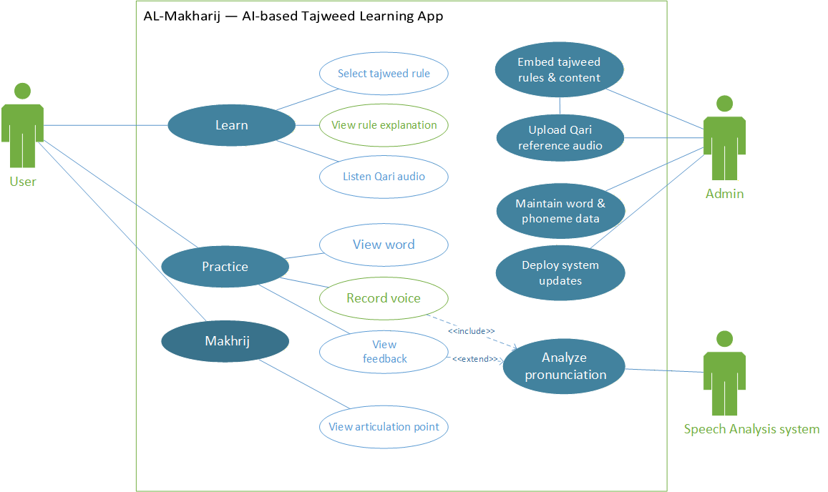

  - Use Case Description
Each Use Case has a description, which describes the functionality that will be built in the proposed system. The template for Use Case description is given below:

<Use case Id: Lessons Tile>
Actors: <User, students>
Feature: <Learn Rule with reference recitation audio>
Use case Id: |  | UC-001
Pre-condition: |  | App must have installed on mobile device.  Basic knowledge of Quran recitation.  Basic Digital literacy to navigate through the application.
Scenarios
Step# | Action |  |  | Software Reaction
1. | User opens the app. |  |  | System displays multiple app features.
2. | User taps on the lesson’s section/tile. |  |  | System displays the list of all basic tajweed lessons.
3. | User selects particular lesson in lessons section. |  |  | System displays the selected lesson’s description and rules with example words and reference audios.
4. | User reads and learns that particular rule and clicks the reference audio button to listen. |  |  | System plays the embedded recorded audio for a specific word in that lesson.
Alternate Scenarios:
1a: If user already has knowledge about tajweed rules, he will directly go to practice section.
Post Conditions:
Step# | Description
 | User gets knowledge of Tajweed rules.
 | User becomes able to practice.
Use Case Cross referenced |  |  | UC-002, UC-003
User Interface reference |  |  | List of all tajweed lessons.  Description of rules with reference audio examples.
Concurrency and Response
Give an estimate of the following
- Only one user per device
- Expected response time is about 1 second because data is locally embedded

<Use case Id: Practice Tile>
Actors: <User, Student, Examiner>
Feature: Practice tajweed rules in real-time with AI based feedback.
Use case Id: |  | UC-002
Pre-condition: |  | User must have knowledge of tajweed rules.  User must have basic English/Urdu literacy.  App must have excess to microphone.  Internet Connection must be stable.  Recording must have done in noise free environment.  User should start recitation with a gap of 2-3 seconds after clicking the record button to ensure full word capture.
Scenarios
Step# | Action |  |  | Software Reaction
1. | User opens the App. |  |  | System displays multiple app features.
2. | User selects the practice section/tile. |  |  | System displays the list of all tajweed practice exercises.
3. | User selects particular exercise in practice section. |  |  | System displays the selected exercise with reference audio and record button, each exercise contains 10 words.
4. | User listens to the reference audio and records his own audio for practice of that particular word by tapping on the record button. |  |  | System takes the user’s audio, converts it to standard format, sends it to backend.  The backend performs the comparison and returns the feedback in json format.
5. | User taps on next or previous button on the interface. |  |  | System displays the next or previous word in that exercise with reference embedded audio.
6. | User views the feedback and knows about his mistakes if any. |  |  | …….
Alternate Scenarios:
1a: if microphone access is not granted, system displays error message.
2a: if Internet is not available, system displays error.
3a: if there is noise in background, feedback is corrupted.
4a: if user already knows the rules, he directly records the audio for analysis.

Post Conditions
Step# | Description
 | User gets to know how much he has learnt.
 | User gets an idea about his mistakes in specific area.
Use Case Cross referenced |  |  | UC-001, UC-003
User Interface reference |  |  | List of all practice exercises.  The reference word and its recitation embedded in a button and the user’s recording button along with a feedback box.  The next and previous buttons to explore and practice
Concurrency and Response
Give an estimate of the following
- Only one user per device
- Expected response time is within 5 sec after the system initialization.

<Use case Id: Makharij Tile>
Actors: <User, Student, Examiner>
Feature: Diagrammatical Explanation of All the makharij, and individual diagrams
elaborating different areas from where the particular makhraj is pronounced.
Use case Id: |  | UC-003
Pre-condition: |  | User must have knowledge of tajweed rule.  User must have basic English/Urdu literacy.  User must have basic recitation knowledge.  User must have basic digital literacy.
Scenarios
Step# | Action |  |  | Software Reaction
1. | User opens the App. |  |  | System displays multiple app features.
2. | User selects the makharij section/tile. |  |  | System displays the main diagram and several individual diagrams based on particular makharij.
3. | User goes through the diagrams and practices on his/her own. |  |  | System makes sure that user exactly knows from where the sound must have made, in order to pronounce Arabic letters properly.
Alternate Scenarios:
1a: if user does not have basic literacy, he might not be able to understand the articulations.
Post Conditions
Step# | Description
 | User gets to know about different articulation points in mouth and throat.
Use Case Cross referenced |  |  | UC-001, UC-003
User Interface reference |  |  | List of all practice exercises.  The reference word and its recitation embedded in a button and the user’s recording button along with a feedback box.  The next and previous buttons to explore and practice
Concurrency and Response
Give an estimate of the following
- Only one user per device
- Expected response time is about 1 second

<Use case Id: Menu Bar >
Actors: <User, Student >
Feature: Information about the application and User Manual
Use case Id: |  | UC-004
Pre-condition: |  | Admin should provide all the necessary details to ensure understanding of the Application features to the new users.
Scenarios
Step# | Action |  |  | Software Reaction
1. | User clicks the menu (three bars) at the top left. |  |  | Menu Window opens as a side bar.
2. | User clicks the user manual link. |  |  | System displays all the listed details to guide new users about the application functionality.
3. | User clicks the about app link. |  |  | System displays information regarding the purpose of application.
4. | User clicks the privacy policy link. |  |  | System displays the privacy policy.
Alternate Scenarios:
1a: if user manual is not provided, user may not understand how the system works.

Post Conditions
Step# | Description
 | User’s reliability on system increases.
 | User understands how the system integrates with AI models to produce corrective feedback.
Use Case Cross referenced |  |  | UC-006
User Interface reference |  |  | --------
Concurrency and Response
Give an estimate of the following
- Only one user per device
- Expected response time is about 1 second

<Use case Id: Data Integration >
Actors: Admin
Feature: Embedding rules and reference Recitation Audios
Use case Id: |  | UC-005
Pre-condition: |  | Admin must collect data from authenticated sources.
 |  | Admin should have permissions to use the content.
 |  | Admin should have access of the backend API.
Scenarios
Step# | Action |  |  | Software Reaction
1. | Admin uploads the reference Qari audio files to Android Studio. |  |  | System saves the audio files locally.
2. | Admin uses a Python script to send the Qari's audio and the Arabic text of that audio to the Espeak-ng for processing. |  |  | Espeak-ng returns a perfect phoneme sequence that is used as a reference for comparison.
3. | Admin writes the description and sample words related to a particular lesson or practice exercise. |  |  | System saves all this information into its local storage and displays on the screen with given layout.
4. | Admin forms a connection link between API and Frontend. |  |  | System gets integrated.
Alternate Scenarios:
1a: if backend is not established properly, system cannot be integrated.
2a: if the audio files are not properly linked and referenced the interface cannot fetch them.
Post Conditions
Step# | Description
 | The Qari's reference audio files are correctly store in Applications local storage and are accessible on tap from the interface buttons.
 | The rule descriptions are properly displayed on the interface.
Use Case Cross referenced |  |  | UC-005
User Interface reference |  |  | --------
Concurrency and Response
Give an estimate of the following
- Only Admin
- Expected response time depends on Deployment time on Hugging Face

<Use case Id: Audio Processing>
Actors: Speech Analysis system
Feature: AI based Tajweed rule evaluation and feedback
Use case Id: |  | UC-006
Pre-condition: |  | System must have access to Microphone.
 |  | Model must have trained and deployed on backend server.
 |  | Reference audios must be stored locally in application storage.
Scenarios
Step# | Action |  |  | Software Reaction
1. | User select exercise in practice section and taps on the record button to record audio for evaluation of correct/ incorrect pronunciation of Tajweed. |  |  | System initializes the buffer, and gets ready to capture the audio and starts recording.
2. | After recording, user taps on the stop button to submit recording. |  |  | As soon as the stop button is hit, system stops capturing, ensures format and sends the audio to backend API via http request.
3. | System receives the audio. |  |  | Wav2vec2 model at backend processes the audio, extracts phonemes sequences, compare extracted ones with the reference phonemes from metadata to produce the phonetic response, and checks the custom logic for Tajweed rule analysis and feedback.
4. | The evaluated result is returned to the flutter application in proper JSON format. |  |  | System displays the accuracy, phonetic feedback and Tajweed feedback based on the analysis.
Alternate Scenarios:
1a: if microphone access is not granted, system displays error message.
2a: if internet connection is not stable, the system displays error message “connection failed. Check if Python API is running.”
3a: if the Tajweed rule like “qalqlah” is not in the evaluation logic, the system returns positive response.
Post Conditions
Step# | Description
Evaluation results are displayed.
As soon as the results are generated, user’s data is removed from the server to ensure privacy.
Use Case Cross referenced |  |  | UC-002, UC-004
User Interface reference |  |  | -----
Concurrency and Response
Give an estimate of the following
- Depends on Hugging Face server capacity
- Expected response time is 3 to 5 seconds on request

Graphical User Interfaces
Give a detailed account of user interfaces included in this project.

<User Interface Id: Home Page>
Interface Id. |  | UI-001
Use case Reference |  | UC-001, UC-002
Snapshot
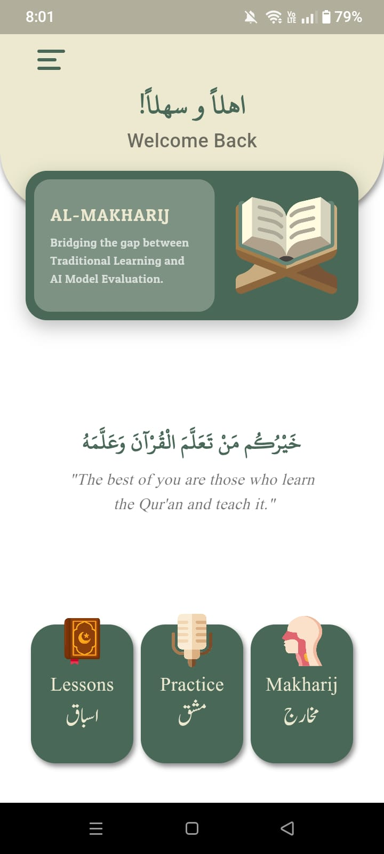

Data dictionary reference
Label | Data dictionary identifier
Lessons  (Button) | Action. Redirects to Lessons Section.
Practice  (Button) | Action. Redirects to Practice Section.
Makharij  (Button) | Action. Redirects to Makharij Section.
Three Bars  ( ) | Action. Redirects to Menu Window.

<User Interface Id: Lessons>
Interface Id. |  | UI-002
Use case Reference |  | UC-001
Snapshot
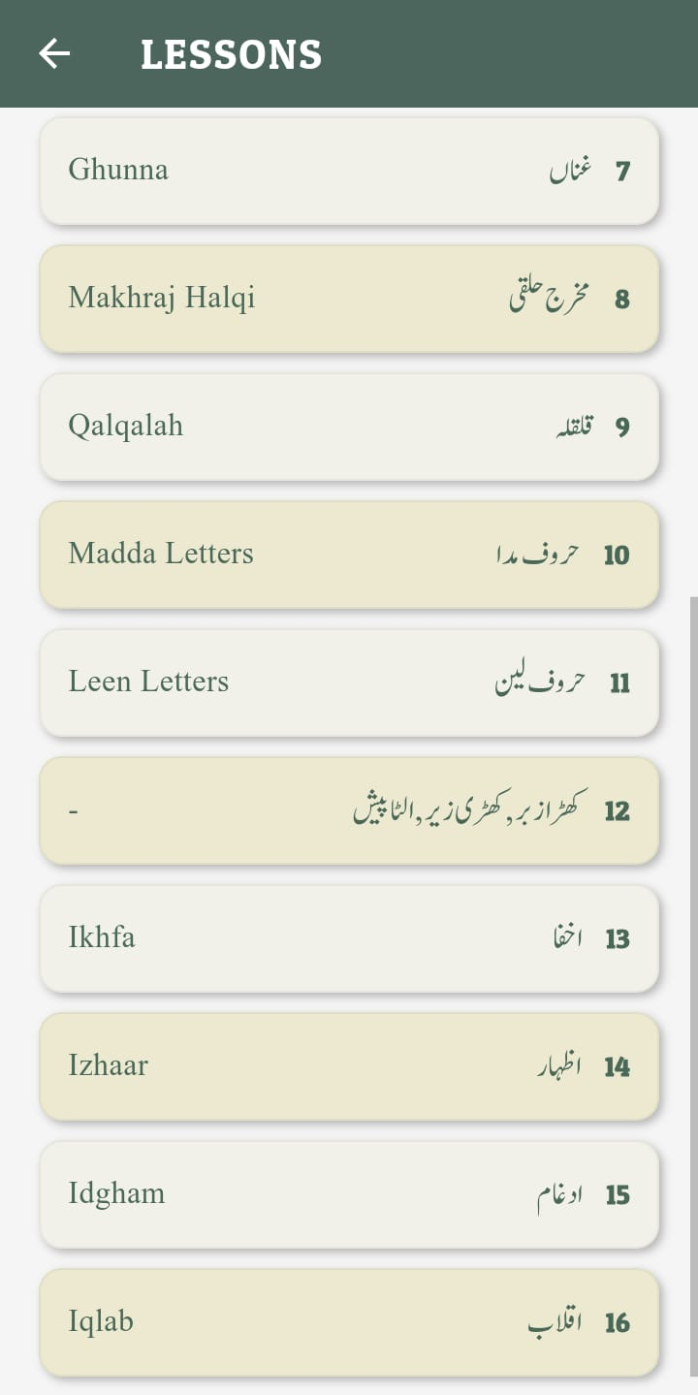
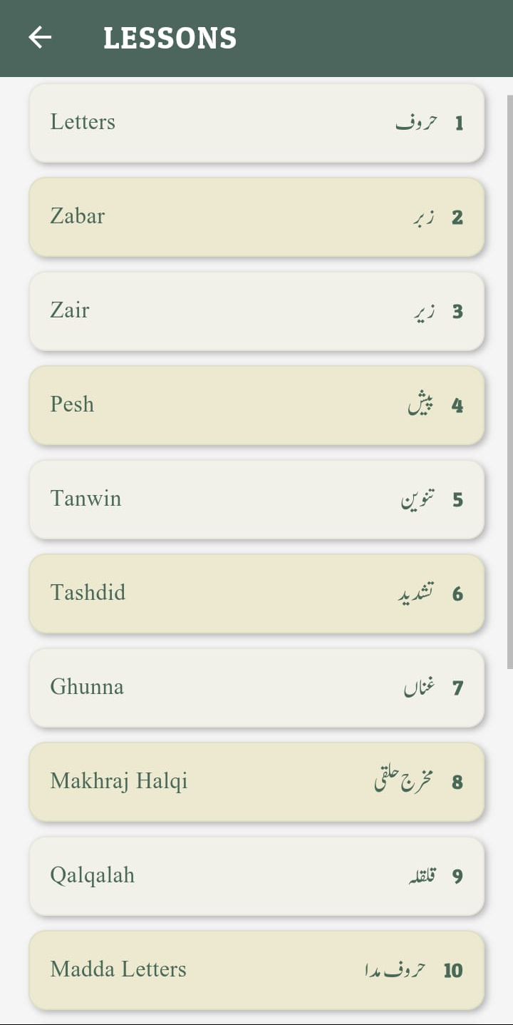
Data dictionary reference
Label | Data dictionary identifier
Letters (Button) | Action, Redirects to letters lesson.
Zabar (Button) | Action, Redirects to Zabar lesson.
Arrow | Action, redirects back to homepage.

<User Interface Id: Zabar, Idgham>
Interface Id. |  | UI-003
Use case Reference |  | UC-001
Snapshot
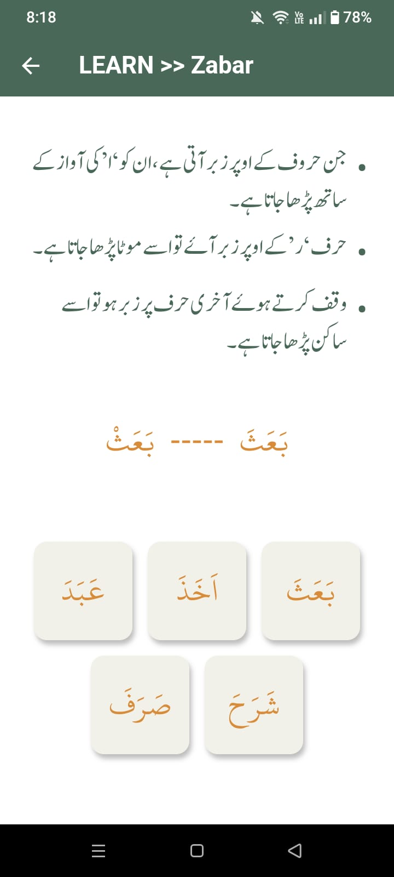
Data dictionary reference
Label | Data dictionary identifier
Rule  Description | Written description of Rules.
Reference  Audio  (Button) | Action. Plays the embedded Reference audio to clarify the rule.
Arabic Text | Written Examples

<User Interface Id: Practice>
Interface Id. |  | UI-004
Use case Reference |  | UC-002
Snapshot
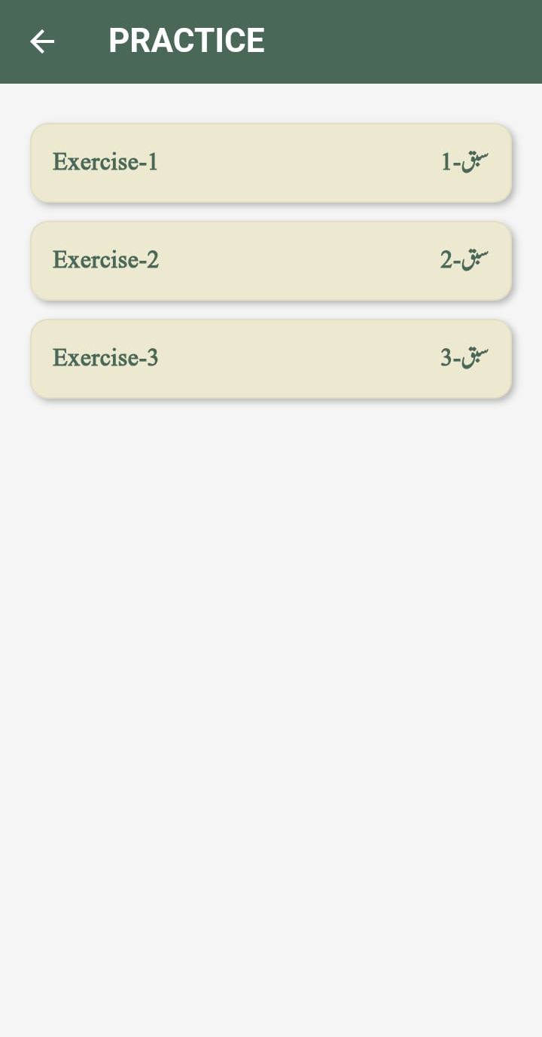
Data dictionary reference
Label | Data dictionary identifier
Exercise1 (Button) | Action, redirects to Exercise1.
Exercise2 (Button) | Action, redirects to Exercise2.
Exercise3 (Button) | Action, redirects to Exercise3.
Arrow | Action, redirects back to homepage.

<User Interface Id: Exercise1, Exercise2>
Interface Id. |  | UI-005
Use case Reference |  | UC-002
Snapshot
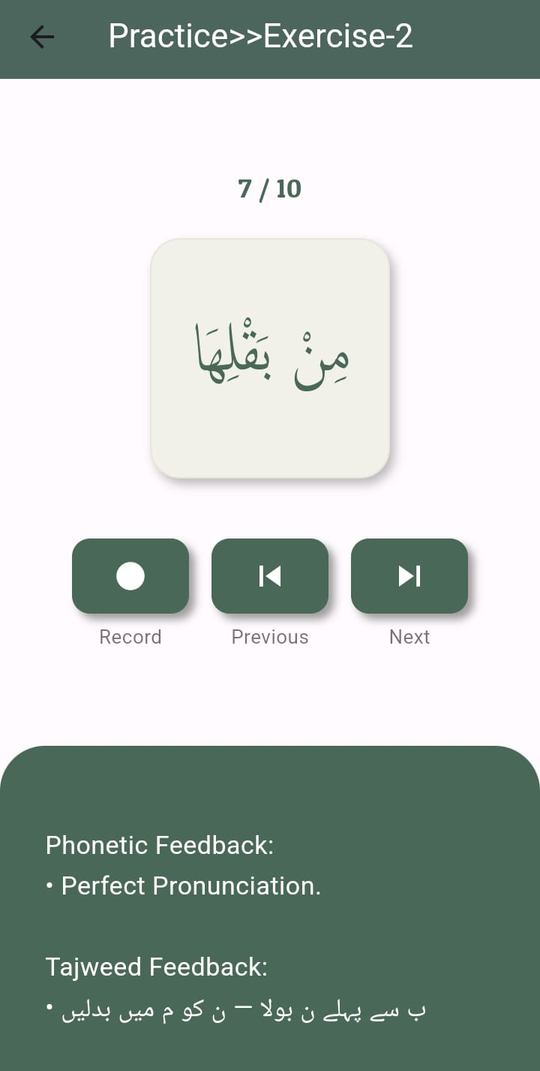
Data dictionary reference
Label | Data dictionary identifier
Reference  Audio (Button) | Action. Plays the embedded Reference audio to clarify the rule.
Record  (Button) | Action. Records user’s real time Audio.
Next  (Button) | Action. Moves user to the next Example.
Previous  (Button) | Action. Moves user to the previous Example.
Feedback  (Container) | Action. Displays the Feedback.

<User Interface Id: Menu Bar>
Interface Id. |  | UI-006
Use case Reference |  | UC-003
Snapshot
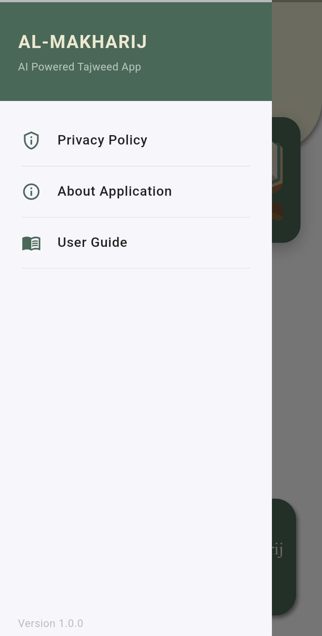
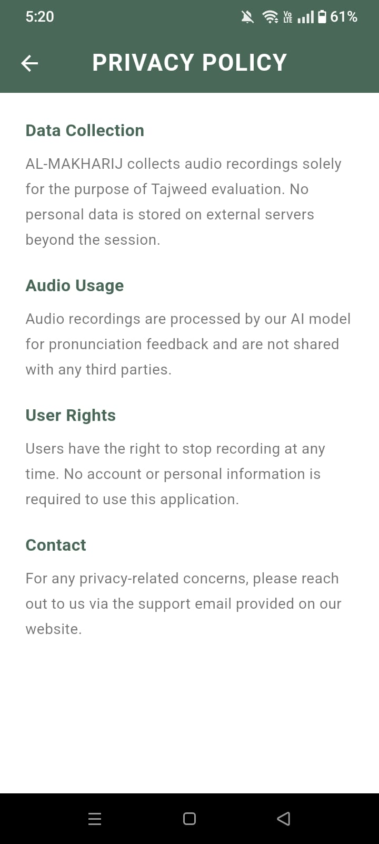
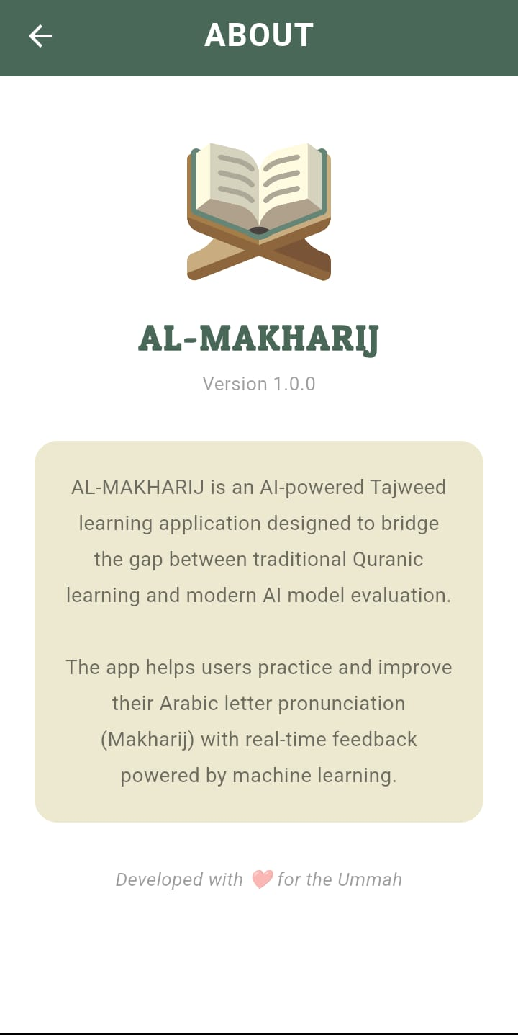
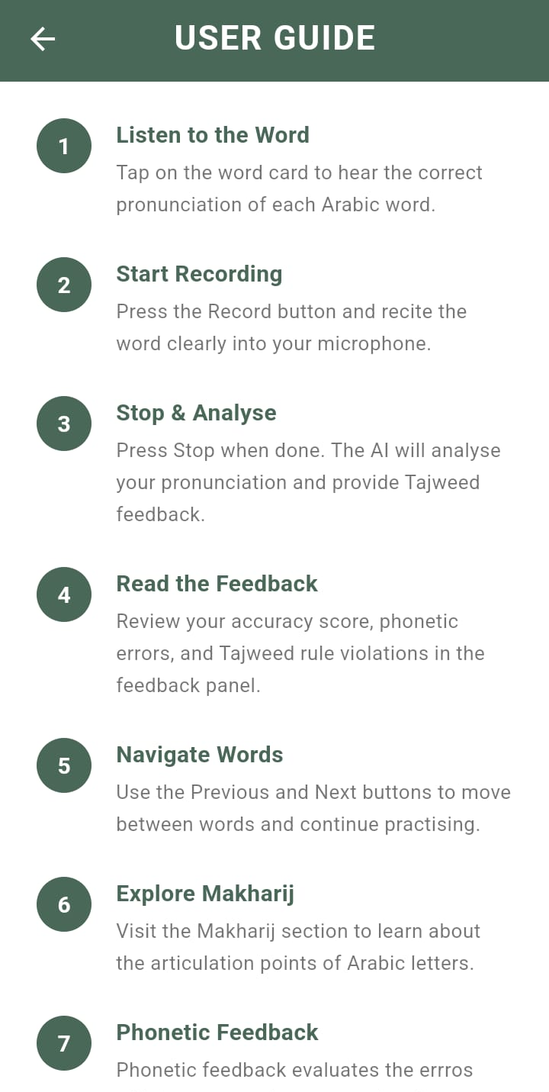
Data dictionary reference
Label | Data dictionary identifier
Privacy Policy | Action, Redirects to Privacy policy section.
About Application | Action, Redirects to About Application section.
User Guide | Action, Redirects to User Guide section.

High Level Design

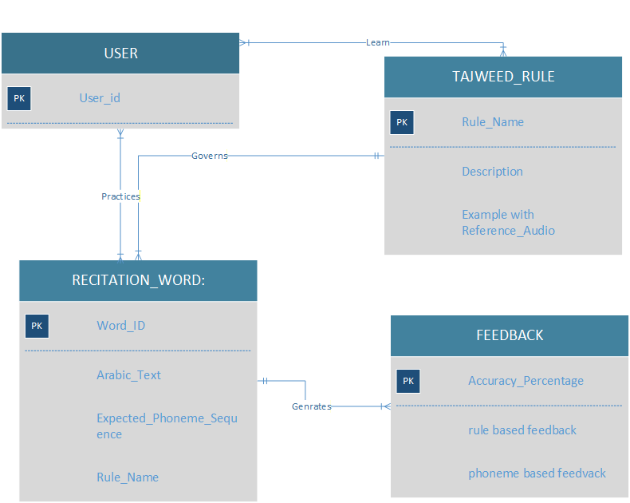
  - ER Diagram

  - Data Dictionary
Data Dictionary is a structured reference that defines each data element in system including its name, size, Data type and constraints. Following are Data Dictionaries:

    - TAJWEED_RULE

< TAJWEED_RULE>
Name | TAJWEED_RULE
Alias | Tajweed Category, Rule
Where-used/how-used | Tajweed rule has used in Lesson section as input to display rule name, description and examples with reference audios. Used in Recitation_Word as foreign key (Rule_Name) to govern which rule applies to each word.
Content description | TAJWEED_RULE = Rule_Name + Description + Examples with Reference_Audios
Supplementary information | Rule_Name: String (50), Not Null e.g. Ikhfa, Izhar, Iqlaab, Idgham. Description: String (500), Not Null. Examples with Reference_Audios: String (100), Not Null
    - RECITATION_WORD
< RECITATION_WORD >
Name | RECITATION_WORD
Alias | Word, Arabic Word, Metadata Entry
Where-used/how-used | Recitation word has used in Practice section as input — word is displayed to user for recitation. Word_ID has sent to backend along with user audio for processing. Expected_Phoneme_Sequence has used by AI model for comparison.
Content description | RECITATION_WORD = Word_ID + Arabic_Text + Expected_Phoneme_Sequence + Rule_Name  * Rule_Name is FK referencing TAJWEED_RULE *
Supplementary information | Word_ID: String (10), PK, Not Null e.g. s0001. Arabic_Text: String (100), Not Null. Expected_Phoneme_Sequence: String (200), IPA format, stored in metadata.xlsm, Not Null. Rule_ID: String (10), FK references TAJWEED_RULE, Not Null.

    - STUDENT
< STUDENT>
Name | STUDENT
Alias | User, Learner
Where-used/how-used | Logical entity representing the person interacting with the system. Used in Practice section — student selects a word, records voice and receives feedback. No physical data is stored as application requires no login or registration.
Content description | STUDENT = Student_ID + Name  * Logically represented only — not physically stored *
Supplementary information | Student_ID: String (10), PK, logical identifier, not physically stored. Name: String (50), optional.  Note: This entity has logically represented only — no user data is stored in the system.

    - FEEDBACK
< FEEDBACK>
Name | FEEDBACK
Alias | Evaluation, AI Result, Tajweed Report
Where-used/how-used | Generated as output in Practice section after user submits recorded audio. Displayed on screen showing phonetic feedback, tajweed rule feedback and accuracy score. Not physically stored — generated in real time by AI backend.
Content description | FEEDBACK = Accuracy_Percentage + Feedback_Tips  [Phonetic_Feedback + Tajweed_Feedback] * Generated in real time — not physically stored *
Supplementary information | Accuracy_Percentage: Float (0.00 to 100.00), AI generated score. Feedback_Tips: String (500), phonetic and tajweed rule based correction tips. Note: This entity has logically represented only — feedback has displayed in real time and not stored.

Requirements Traceability Matrix

Sr. # | Feature | Use case ID | UI ID | Priority | Build Number | Use Case Cross reference  (Related Use Cases)
 | Lesson Tile | UC-001 | UI-001 | High | 2.0 |  | UC-003, UC-004
 | Practice Tile | UC-002 | UI-002 | High | 3.0 |  | UC-005
 | Makhraj Tile | UC-003 | UI-003 | Medium | 4.0 |  | UC-001
 | Data Integration | UC-004 | N/A | Medium | 5.0 |  | UC-001, UC-002, UC-003
 | Audio Processing | UC-005 | N/A | High | 6.0 |  | UC-002

The columns carry the following meaning:

- Feature: Lists system features based on which use cases are built.
- Use Case ID: Write the ID of the use case for easy lookup
- UI ID: Write the user interface ID for this use case.
- Priority: Give an appropriate rating to each use case according to its priority
- Build Number: Write the reference number to which this feature belongs.
- Use Case Cross Ref: Write the related use cases separated with commas.

Risk Analysis

Risk 1. Low Accuracy of System

Risk Identification | The Wav2Vec2 model may fail in processing Audio to accurately detect Arabic phonemes
Risk Drivers | The model is not fully optimized for Arabic phoneme recognition
Percentage Impact | 80%
Mitigation Plan | The model was fine-tuned for Arabic phonemes

Risk 2: Backend Server Downtime
Risk Identification | Hugging Face Spaces server may become unavailable
Risk Drivers | Free hosting has limitations and sometimes server enters sleep mode when idle for a certain period
Percentage Impact | 60%
Mitigation Plan | Server wake-up time is approximately 30-60 seconds. A clear error message is displayed to the user.

Risk 3: Issues in Audio Quality
Risk Identification | Noisy or Poor audio quality may cause the model to detect incorrect phonemes
Risk Drivers | Low quality of microphone and Background noise may affect audio clarity
Percentage Impact | 55%
Mitigation Plan | Users are advised to record in a quiet environment for accurate results

Risk 5: Internet Connectivity
Risk Identification | Practice section will not generate feedback or fully function without an active internet connection
Risk Drivers | Audio processing requires active internet connection
Percentage Impact | 70%
Mitigation Plan | An error message is displayed to the user stating "No internet connection available"

Cost Estimation Sheet

 | Software development cost | RS.0 software is developed by students as part of their project
 | Packaged software | RS.0 All required Android Studio (Free), VS Code (Free), Flutter (Free), Python (Free), Google Colab (Free)
 | Hardware | RS.0 Personal Laptops
 | Network | RS.0 Hugging Face Spaces (Free tier), GitHub (Free)
 | Client | RS.0 no client is involved, this is just an academic project
 | Misc. | RS.0 No additional costs
 |  | Total cost =0

References
[1] Q. Xu, A. Baevski, and M. Auli, "Simple and Effective Zero-shot Cross-lingual Phoneme Recognition," arXiv preprint arXiv:2109.11680, 2021. [Online]. Available: https://arxiv.org/pdf/2109.11680
[2] A. Abdelfattah, M. I. Khalil, and H. Abbas, "Automatic Pronunciation Error Detection and Correction of the Holy Quran's Learners Using Deep Learning," arXiv preprint arXiv:2509.00094, 2025. [Online]. Available: https://arxiv.org/abs/2509.00094
[3] A. Kucukmanisa, D. Gelmez, S. S. Calik, and Z. H. Kilimci, "Enhancing Quranic Learning: A Multimodal Deep Learning Approach for Arabic Phoneme Recognition," arXiv preprint arXiv:2511.17477, 2025. [Online]. Available: https://arxiv.org/abs/2511.17477
[4] A. Baevski, Y. Zhou, A. Mohamed, and M. Auli, "wav2vec 2.0: A Framework for Self-Supervised Learning of Speech Representations," arXiv preprint arXiv:2006.11477, Facebook AI Research, 2020. [Online]. Available: https://arxiv.org/abs/2006.11477
[5] HuggingFace, "facebook/wav2vec2-xlsr-53-espeak-cv-ft," HuggingFace Model Hub, 2023. [Online]. Available: https://huggingface.co/facebook/wav2vec2-xlsr-53-espeak-cv-ft
[6] Google, "Flutter — Build Apps for Any Screen," Flutter Documentation, 2023. [Online]. Available: https://flutter.dev
[7] S. Ramirez, "FastAPI — Modern Web Framework for Building APIs with Python," FastAPI Documentation, 2023. [Online]. Available: https://fastapi.tiangolo.com
[8] HuggingFace, "HuggingFace Spaces — Deploy Machine Learning Applications," HuggingFace Documentation, 2023. [Online]. Available: https://huggingface.co/spaces
[9] Kensho Technologies, "pyctcdecode — CTC Beam Search Decoder for Speech Recognition," GitHub, 2023. [Online]. Available: https://github.com/kensho-technologies/pyctcdecode
[10] B. McFee et al., "Librosa — Python Package for Music and Audio Analysis," Librosa Documentation, 2023. [Online]. Available: https://librosa.org
[11] Google, "Android Studio — Official IDE for Android Development," Android Developers, 2023. [Online]. Available: https://developer.android.com/studio
[12] GitHub, "Git Large File Storage," GitHub Documentation, 2023. [Online]. Available: https://git-lfs.github.com
[13] International Phonetic Association, "International Phonetic Alphabet," IPA, 2023. [Online]. Available: https://www.internationalphoneticassociation.org

Appendices

Appendix A — Metadata File Structure
The metadata file (metadata.xlsm) contains the following columns used by the backend for phoneme comparison and tajweed rule evaluation:
Column | Description
ID | Unique word identifier e.g. s0001
Word | Arabic text of the recitation word
Phenome | Expected IPA phoneme sequence
Rule | Tajweed rule applicable to the word e.g. Ikhfa, Izhar, Iqlab, Idgham

Appendix B — API Endpoint Reference
The backend API is deployed on Hugging Face Spaces and exposes the following endpoint:
Detail | Information
Base URL | https://muteeah-tajweed_backend.hf.space
Endpoint | /upload-audio
Method | POST
Parameters | word_id (string), file (audio file)
Response | accuracy, phonetic_feedback, tajweed_feedback

Appendix C — Tools and Technologies Used

Tool / Technology | Purpose
Flutter | Mobile application development
Python | Backend development
Fast API | REST API framework
Wav2Vec2 XLSR-53 | Pretrained speech recognition model
Hugging Face Spaces | Backend deployment
GitHub | Version control
Git LFS | Large audio file storage
Android Studio | Flutter app testing
Google Colab | Model testing and prototyping
Microsoft Excel | Metadata storage

Appendix D — Tajweed Rules Covered
Rule | Description
Ikhfa | Noon is hidden with ghunna before specific letters
Izhar | Noon is pronounced clearly before throat letters
Iqlab | Noon is converted to Meem before Ba
Idgham | Noon merges into the following letter

GitHub Repository link:
https://github.com/fatimahh20/MY_TAJWEED_APP

